Sample Article Title
Sample Author

Abstract
This is a sample article in order to facilitate the writing of articles for the SARA journal. It can be used as a template. The idea of this template is to give all articles in the SARA journal the same look and feel.

Fonts
The font used is Calibri, the font size is 11 pt. for normal text. The article title, the author name and the section headings are bold. Figure and table captions will be in font size 10 pt. as shown later below. There should be no blank line between the heading of a section and the text. There should be, however, a blank line between two sections as demonstrated above between the “Abstract” and the “Fonts” section.

Figures
Figures will be important to show results, equipment. Figures shall be numbered and referenced in the text as demonstrated here: Figure 1 shows a 3-m dish.

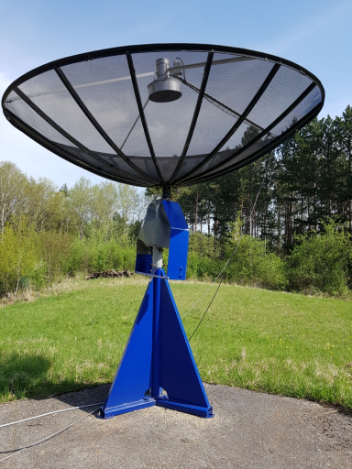

Figure 1: 3-m dish for 1.4 GHz

In this case, the figure has been centered on the page and the figure caption has been set below. It is also possible to put the figure to the left side and put the caption to the side as demonstrated in figure 2:

Figure 2: Same 3-m dish

A word on figure numbering: Although it is convenient to use auto-numbering it is requested not to use this feature. The reason is that when several articles are combined into the journal, this autonumbering will eventually carry over from a previous article and things get messy.
Also care must be taken that figures and figure captions are not separated by a page break.
If a figure contains text please make sure that this text is legible.

Tables, abbreviations and units
Tables will follow the same scheme as figures. An example is given in table 1 where some fictitious results are presented. Abbreviations are used here as well. These abbreviations are Modified Julian Date (MJD), left hand circular polarization (LHC), right hand circular polarization (RHC) and Jansky [Jy].

MJD | LHC [Jy] | RHC [Jy] | Event duration [s] | Fluence [Jy ms]
53757.289 | 26 | 19 | 0.03 | 223
53757.488 | 45 | 17 | 0.01 | 432
53757.620 | 33 | 32 | 0.08 | 531
53757.668 | 45 | 21 | 0.03 | 449

Table 1: Observation results at various epochs

You will note that the abbreviations for seconds and milliseconds are not explicitly explained as these are standard SI units.
If you insert a table from other programs please ensure that the table remains clearly legible.

Formulas
Please use a formula editor to create nice looking equations. Don’t forget to number them. Equation 1 is the radiometer equation and be created by using Word’s own formula editor or pasting a LATEX expression into the Word document.

$T_{sys}=σ_{rms}\sqrt{Δν⋅t}$ (1)

Equation 2 gives the 3 dB beam width of a telescope with a diameter D at a wavelength λ.

$W=arcsin\left(1.22\frac{λ}{D}\right)$ (2)

Citations
Frequently one will cite other work and proper references shall be given. There are two styles available for SARA journal articles. The first style is a number in square brackets such as used in this example for the work of E. Bajaja et. al. [1]. The other option is to put name and year in square brackets [Bajaja-2005]. The corresponding citations are shown in the reference example section below.

Author guide
SARA has published an author guide on their web site. More details are given there with respect to the guidelines to be observed when writing an article.

References
[1] E. Bajaja et. al, A high sensitivity HI survey, A&A 440, 767–773 (2005)
[Bajaja-2005] E. Bajaja et. al, A high sensitivity HI survey, A&A 440, 767–773 (2005)

About the author: This author has been enthusiastic about radio astronomy for several decades. He worked as an engineer in an electronics company and is now retired. His greatest ambition is to become the most respected author of articles for the SARA journal. You can contact the author at author@mydomain.com

