Article Title
Author

This is some article text.

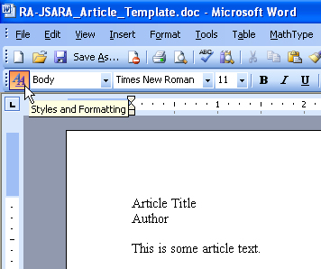

Figure 1 — To access the styles toolbox, click the Styles and Formatting toolbar button.

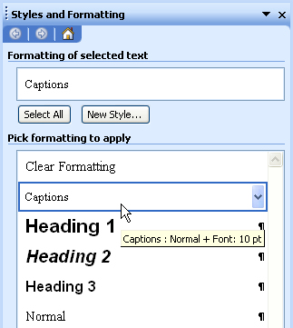

Figure 2 — Then highlight any text and click on the appropriate style (“Normal” or “Captions”).

